QUESTIONS FOR C LANGUAGE
- Write a program to create a box pattern with the introduction using printf only as shown here:
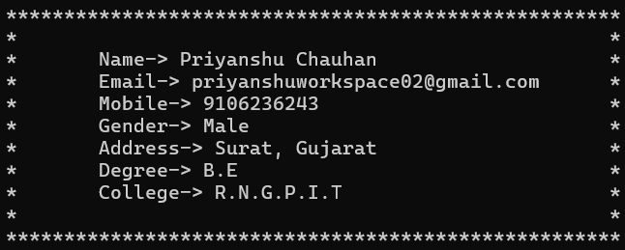

- Write a program to create a star pattern using printf as shown here:


- Write a program to create a simple calculator.
- Write a program to find cube and square of given number.
- Write a program to find simple interest.
HINT: PRN/100
- Write a program to find area of circle.
- Write a program to find area of square and rectangle.

# LOOP:
- Write a program to check whether a number is even.
- Write a program to check whether a person is eligible to vote.
- Write a program to check whether a given year is a leap year.
- Write a program to check a number is divisible by 5.
- Write a program to find the greater of two numbers.
- Write a program to check whether a number is zero or non-zero.
- Write a program to check whether a character is an alphabet, digit or special character using else-if ladder.
- Write a program to check whether a number is divisible by both 3 and 5 using nested if.
- Write a program to check if a triangle is valid and also equilateral, isosceles or scalene using nested if.
- Write a program to classify a person based on age (child, teenager, adult, senior) using else-if.
- Write a program to check temperature range (cold, warm, hot, very hot) using else-if ladder.
- Write a program to display traffic light meaning (red, yellow, green) using switch.
- Write a program to print number from 10 to 1 using while loop.
- Write a program to print the sum of first 20 numbers using for loop.
- Write a program to find the factorial of given number.
- Write a program to find the sum of digits of a number.
HINT: (1234 => 1 + 2 + 3 + 4)
- Write a program to find sum of all even and odd numbers separately from 1 to 10.
- Write a program to display the multiplication table of given number.
- Write a program to find the power of a number using loop.
- Write a program to find the sum of first and last digit of number.
HINT: (number= 4216 => 4 + 6 = 10)
- Write a program to find the minimum digit of given number.
HINT: (5167 => 1 is min number)

# ARRAY:
- Write a program to find sum of all even elements of a given array.
- Write a program to create a new array of only odd numbers from a given array elements.
- Write a program to find min and max elements from a given array.
- Write a program to find second largest number from a given array.

